Jhargram Raj College
English Department
NOTICE

ENG/N-10 29.03.2022

As per Ref no. VU/UG/1067/2022 dated 28.03.22 and JRC Cir no 52 dated 29.03.2022, commencement of classes for Semester II in English Department will be from 01.04.2022.

Class Routine has been put up in the departmental notice board.

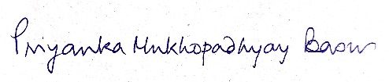
Head
Department of English

